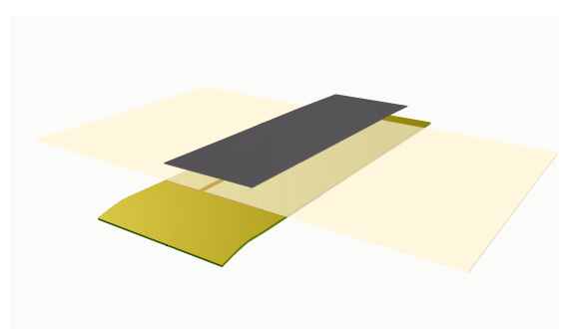
SPLICING TAPES FOR RELEASE PAPERS
TOP SPLICE

The tapes available for the top splice have a special release coat on the tape surface which ensures easy separation of the synthetic leather from the splice

BACK SPLICE

A choice of 3 paper based tapes with very specific properties and easy to apply. Recommended for both PU and PVC release papers.
A unique range of single sided self-adhesive tapes for splicing surface treated release/casting papers as used in the manufacture of SYNTHETIC LEATHER. The system consists of:

TOP SPLICE

BACK SPLICE

TOP SPLICE TAPES
For PVC Casting Papers only use:

88-0l HT Polyester Acrylic Splicing Tape – Clear (see data sheet online)

For PU and PVC Casting Papers use:

88-06 HT Polyester Silicone Splicing Tape – Black. Regarded as the best top splice tape available. (see data sheet online)

BACK SPLICE TAPES
80-50 Adhesive Paper Tape - Green

0.10 mm thick. This tape is flexible and conformable with a high level of adhesion, shear and temperature resistance- 200 deg C short term. Ideal for PU Production. (see data sheet online)
80-60 High Performance Kraft Paper Tape - Brown Ref Code - 7102

0.16mm thick. This tape offers the highest level of adhesion, shear properties and temperature resistance (240 deg C for 3 minutes. Especially recommended for PVC casting, heavily embossed papers and the newer type of smooth casting papers with surface coatings on the back (see data sheet online)

80-55 Economy Kraft Paper Tape - Brown

0.17 mm thick . It has the advantage of much lower cost with excellent ‘quick-stick’ properties. (see data sheet online).

General Properties and Application

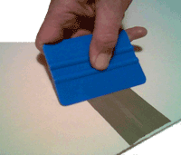
1). The tape surface of 88-06 and 88-01 has been specially treated to ensure separation of the synthetic leather from the splice in the same way as it separates from the release paper. This ensures continuous production of synthetic leather.

2). All tapes are easy to apply. Application with our free Plastic Applicator is recommended for a secure bond, including heavily embossed papers. Under cold conditions a warm iron can be moved over the splice to enhance adhesion. For the Back Splice abrasion of the release paper prior to applying the Back Splice will improve adhesion further.

3). The Splicing Tapes will withstand the temperature conditions encountered in the production of synthetic leather and will last through six or seven production cycles.

4). The Splicing Tapes can be stored up to 12 months prior to use, but they must be stored in dry conditions at around 25
deg C inside the original packaging. Protection from water/humidity, extreme temperatures and direct sunlight is necessary.

5). Our Customer Care Service is outstanding. Dispatch can be arranged worldwide by airfreight immediately after receipt of order.

Dimensions and Case Quantities:
88-06 : 50mmx66m (36 rolls per case) 75mmx66m (24 rolls per case)
88-01 : 72mmx66m (16 rolls per case)
80-50 : 75mmx33m (l2 rolls per case)
80-55 : 75mmx66m (18 rolls per case)
80-60 : 75mmx33m (l2 rolls per case)

